Investify

### Project Proposal

## 

## Supervisor

Dr. Adeel Ansari

## Submitted by

Muhammad Faseeh

2012390

Safwan Uddin Mairaj

2012403

**Faculty of Computing and Engineering Sciences**

Shaheed Zulfiqar Ali Bhutto Institute of Science and Technology, Karachi.

[04-09-2023]

# Introduction

Investify is an online platform that facilitates and investment opportunities. The platform provides a space for business owners looking for potential investors. Likewise, investors can search for businesses that match their investment criteria. Our platform aims to provide a seamless solution for entrepreneurs to list their businesses and seek investments. It will bridge the gap between ambitious entrepreneurs and potential investors, offering a user-friendly interface and robust features to support both parties.

# Objective

The main objective of our marketplace is to support new startups and small-scale businesses by connecting them with the right investors to solve their problems related to funding.

# Problem Description

There is a notable absence of a dedicated platform that deals in business investments only. This gap in the market poses significant challenges for entrepreneurs looking for small investment for their ventures or individuals seeking to invest in small businesses. So, we will be creating this platform to address the pressing need for a dedicated platform in Pakistan where business owners can seamlessly look for investors. Suppose a businessman is looking for Rs 25,000 investment to expand his business, so he can list his business on our platform and ask for the required investment in returns will be given according to revenue sharing model in which some percentage of business profit will be shared with the investor for some limited period of time and legal agreement will be made between both the parties.

# Methodology

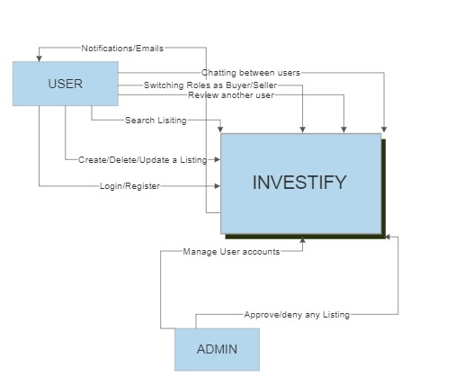

# Project Scope

The scope of this project will be to help people in building their business by asking for investment. This project can start a culture of building small-scale businesses and startups and eventually, this will also help in building the economy of Pakistan.

# Project Features

Our project will have the following features:

* **Investor Features:**

1. Profile creation.
2. Searching for your desired business between listings.
3. In app notifications/emails.
4. Chat platform to facilitate secure and efficient communication between investee and investors.

* **Investee Features:**

1. Business registration.

1. Listing Creation.
2. Listing Update or Delete.
3. Visualizing business data in the form of graphs.

* **Admin Features:**
  1. Manage investor/investee accounts which includes the ability to suspend user accounts that violate marketplace policies or engage in fraudulent activities.
  2. Approving or deleting any listing.

# Feasibility Study

**Risks Involved:**

To access our marketplace users must have a Smartphone/Laptop/Desktop having the latest version of any web browser and a proper internet connection.

**Resource Requirement:**

* Smartphone/Laptop/Desktop
* Web browser
* Internet Connection

# Solution Application Areas

Target audience: Entrepreneurs and business owners, investors, startups, small business owners, professionals, and industry experts.

Goal: To connect successful businessmen, investors with small-scale businesses and startups in need of investments.

# Tools/Technology

**Hardware Tools**

* Laptop
* Android Phone

**Software Tools**

* VS code
* Google Chrome
* Firebase
* Node

# Expertise of the Team Members

Our team comprises two members including Muhammad Faseeh, and Safwan Uddin Mairaj. Both members have basic knowledge of Frontend Web Development, Database Design, Project Documentation, etc. In addition, we will be learning new technologies while working on our project gradually.

# Milestones

* **FYP 1:**

70% Documentation (SRS, SDS, ERD)

30% Implementation (Coding + UI)

* **FYP 2:**

70% Implementation (Coding)

30% Documentation (Test Cases)

# Project Schedule

**FYP1:**

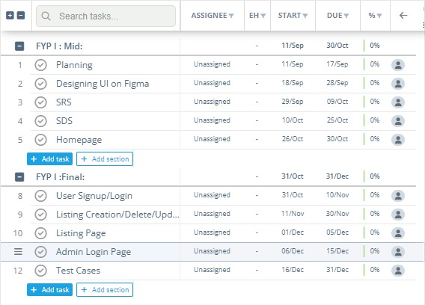

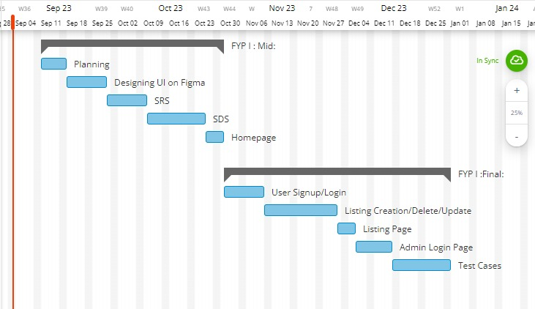

**FYP 2:**

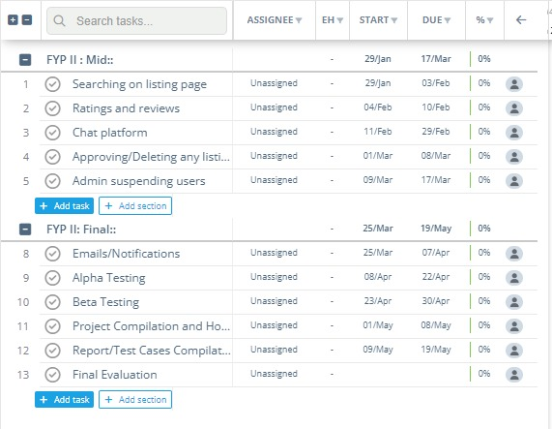

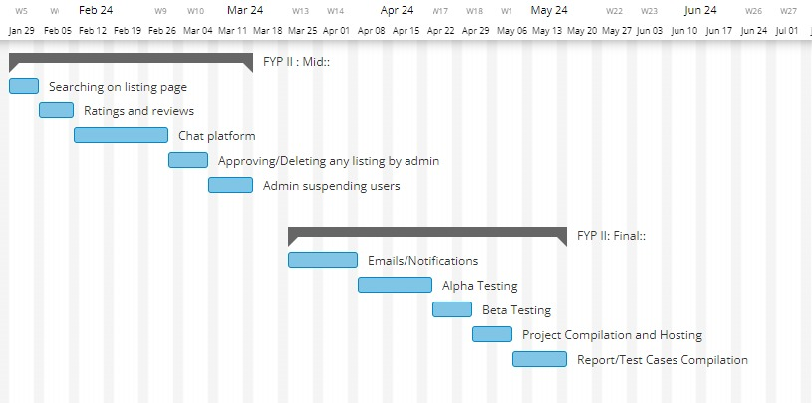

# Work Breakdown Structure

**FYP I (Fall Semester):**

1. Research.
2. Planning.
3. Project initiation.
4. Documentation (70%).
5. Implementation (30%).

**FYP II (Spring Semester):**

1. Implementation (70%).
2. Testing and debugging.
3. Documentation (30%).

# References

* <https://nditoeka.com/how-to-write-your-final-year-project-proposal.html>.
* <https://www.smartdraw.com/>
* <https://app.instagantt.com/r#projects/hsOyttoLKmZtHTkb4rQ5/hsOyttoLKmZtHTkb4rQ5>
* [How to Create a Gantt Chart](https://www.gantt.com/creating-gantt-charts)
* [Business News Daily: Small Business Solutions & Inspiration - BusinessNewsDaily.com](https://www.businessnewsdaily.com/)